# ABSTRACT

# **PROBLEM STATEMENT:**

Creating a user-friendly recipe website that caters to the diverse needs of home cooks poses significant challenges. Existing platforms often fall short in providing a comprehensive range of recipes tailored to different diets, leaving users with limited choices. Furthermore, the lack of clear and beginner-friendly instructions complicates the cooking process for those just starting their culinary journey. Recognizing these gaps, our objective is to develop a new website that not only prioritizes ease of use but also boasts an extensive collection of recipes spanning various diets. Tailored to the needs of beginners, the platform will feature crystal-clear instructions, turning the cooking experience into an enjoyable and accessible activity. The overarching goal is to foster a sense of inclusivity, making the website a welcoming hub for all, irrespective of their cooking expertise or dietary preferences.

# **Introduction:**

This document provides an overview of a recipe website developed using Django, a Python-based web framework. The website's main goal is to offer users a place to discover, share, and explore various recipes. It allows users to find recipes easily, contribute their own, and connect with others who enjoy cooking. The website is designed to be user-friendly, offering categories for different cuisines, dietary preferences, and cooking difficulty levels to make searching for recipes simple and enjoyable.

# **User-Centric Functionality:**

The primary objective of the website is to create a seamless and enjoyable user experience. Users can effortlessly navigate through a diverse array of recipes, ranging from traditional favorites to innovative culinary creations. The website goes beyond being a repository of recipes; it acts as a hub for individuals passionate about sharing their culinary expertise.

# **Feature Highlights:**

* A user-friendly interface allows users to effortlessly discover a wide variety of recipes through intuitive navigation and visually appealing layouts.
* Users are empowered to contribute their own recipes, fostering a sense of community and knowledge-sharing among cooking enthusiasts.
* Comment sections and interactive forums facilitate discussions and connections among users, creating a dynamic culinary community.
* Recipes are meticulously categorized into various sections, including cuisines, dietary preferences, and cooking difficulty levels. This thoughtful organization ensures users can quickly find recipes that align with their specific preferences and skill levels.
* Users have the option to create personalized profiles, adding a social dimension to the platform. Profiles showcase users' contributions, favorite recipes, and a brief bio, enhancing the sense of community.
* An advanced search functionality, coupled with robust filtering options, enables users to pinpoint recipes tailored to their individual needs, be it dietary restrictions or specific cuisine preferences.

# **Design Philosophy:**

* The website boasts an intuitive and visually pleasing design, ensuring a smooth and engaging browsing experience for users of all levels of technical expertise.
* Recognizing the diverse ways users access online content, the website is meticulously optimized for mobile devices, ensuring consistent functionality and aesthetics across platforms.
* Recipe pages feature high-quality images, and where applicable, step-by-step videos to provide users with a comprehensive visual guide, enhancing the learning and cooking experience.

# **Future Expansions:**

* Introducing features for users to virtually cook together, fostering real-time collaboration and learning.
* Exploring opportunities to integrate with smart kitchen devices, allowing users to seamlessly sync recipes with their smart appliances.
* Implementing artificial intelligence algorithms to provide personalized recipe recommendations based on users' preferences and cooking history.

# **Technology being used:**

## Django Framework:

**Overview:** Django serves as the backbone of our recipe website, offering a robust and well-structured Python-based web framework. Its reputation for simplicity, scalability, and flexibility makes it an ideal choice for developing feature-rich web applications.

**Simplicity:** Django follows the "Don't Repeat Yourself" (DRY) principle, streamlining development by minimizing redundancy. Its clear and concise syntax accelerates the coding process.

**Scalability:** The framework's modular design allows for the easy addition of new features, ensuring that the website can evolve seamlessly as user needs and functionalities expand.

**Flexibility:** Django's flexibility enables developers to tailor the application to specific requirements, from intricate backend logic to user interfaces.

## HTML, CSS, JavaScript (Frontend Development):

**HTML (HyperText Markup Language):**

HTML forms the structural foundation of our website, defining the layout and organization of content. It provides a standardized structure for presenting information on the user's browser.

**CSS (Cascading Style Sheets):**

CSS enhances the visual appeal and presentation of the website. It dictates the styling, layout, and design elements, ensuring a cohesive and aesthetically pleasing user interface.

**JavaScript:**

JavaScript introduces interactivity to the website, enabling dynamic content updates without requiring page reloads. This client-side scripting language enhances the user experience through features like real-time form validation and asynchronous requests.

**Responsive Design:**

The combined use of HTML, CSS, and JavaScript contributes to the implementation of a responsive design. The website adapts seamlessly to various screen sizes, ensuring a consistent and user-friendly experience across devices.

## SQLite Database:

**Lightweight and Serverless:**

SQLite is chosen as the database engine for its lightweight nature and serverless architecture. It operates as a self-contained, file-based database, eliminating the need for a separate database server. This simplicity aids in easy deployment and management.

**Scalability and Performance:**

While SQLite is an excellent choice for smaller to medium-sized projects, its limitations in handling concurrent write operations make it less suitable for extremely high-traffic websites. However, for our recipe website, SQLite provides a reliable and performant solution.

**Self-contained:**

SQLite databases are self-contained files that can be easily transported, backed up, and managed. This self-contained nature aligns well with the project's requirements and facilitates efficient data handling.

# **RECIPES MANAGEMENT:**

## ADMINISTRATIVE FUNCTIONALITIES:

Our recipe website extends comprehensive administrative functionalities to empower administrators in managing content effectively. The admin panel acts as a control center, allowing seamless creation, modification, and removal of both recipes and blogs. This ensures that the website's content remains dynamic, relevant, and aligned with the evolving preferences of the community.

**CREATE, EDIT, DELETE RECIPES:**

**Recipe Creation:**

The admin interface provides a user-friendly form allowing administrators to add new recipes effortlessly. This form includes fields for recipe name, ingredients, cooking instructions, images, and other relevant details.

**Recipe Editing:**

Admins have the capability to modify existing recipes. This includes updating ingredients, refining cooking instructions, adding or removing images, and adjusting any other details to improve accuracy or reflect user feedback.

**Recipe Deletion:**

The deletion feature ensures that administrators can remove recipes that are outdated, irrelevant, or no longer align with the website's content standards. This helps maintain a curated collection of high-quality recipes.

**Version Control:**

To enhance accountability and maintain a version history, our system may incorporate version control mechanisms. Admins can track changes made to recipes, making it easier to revert to previous versions if necessary.

**CREATE, EDIT, DELETE BLOGS:**

**Blog Creation:**

The admin dashboard facilitates the creation of blogs, providing a form where administrators can compose and publish articles. Blogs may cover diverse topics, including cooking tips, culinary trends, and personal experiences with recipes.

**Blog Editing:**

Admins can edit existing blogs to ensure the content remains current and relevant. This includes updating text, adding images, or embedding multimedia elements to enhance the overall readability and engagement of the blog.

**Blog Deletion:**

Similar to recipes, the admin panel grants the authority to delete blogs. This flexibility allows administrators to manage the blog repository, ensuring that outdated or redundant content is promptly removed.

Content Moderation:

To maintain the quality and integrity of the content, the admin panel may include moderation features. Admins can review and approve user-submitted recipes and blogs before they are published, preventing inappropriate or low-quality content from being displayed.

# **Database Tables:**

Blog Table:

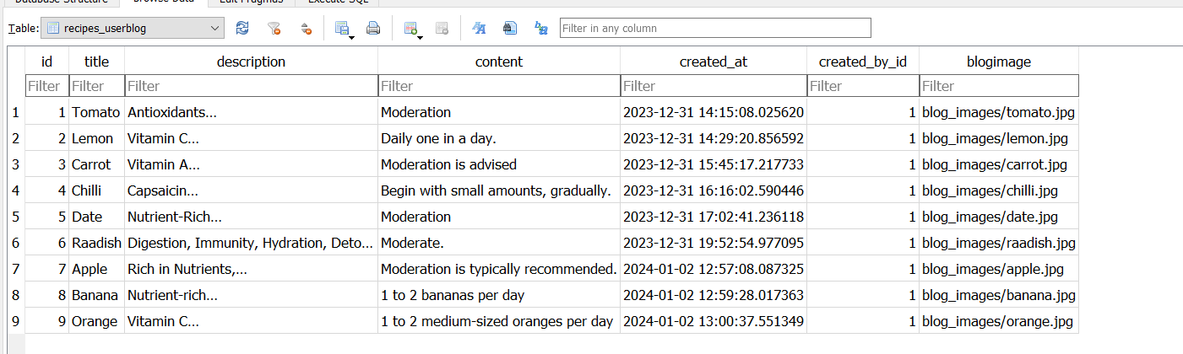

Continental Food Table: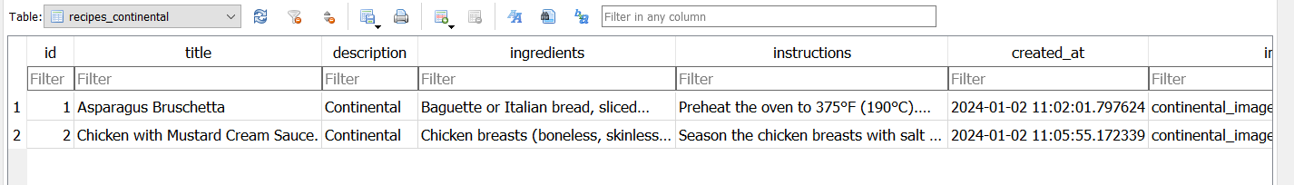

Desi Food Table: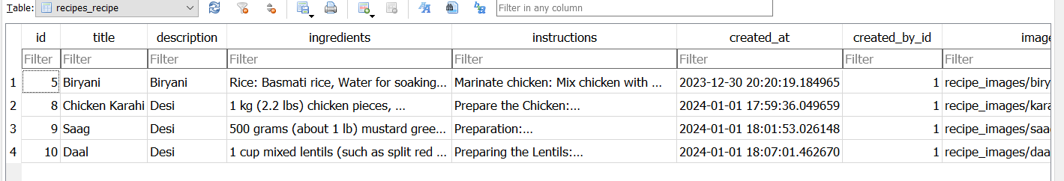

Fast Food Table: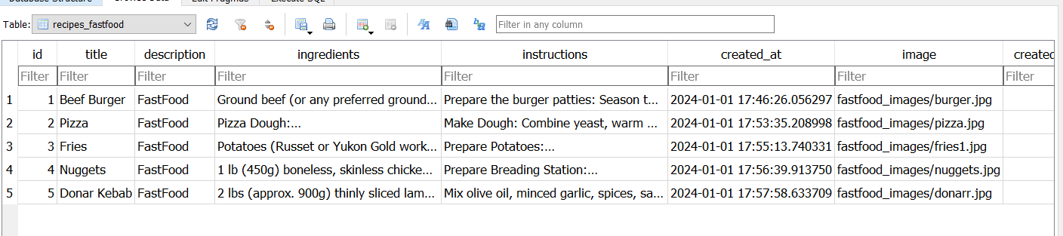

Italian Food Table: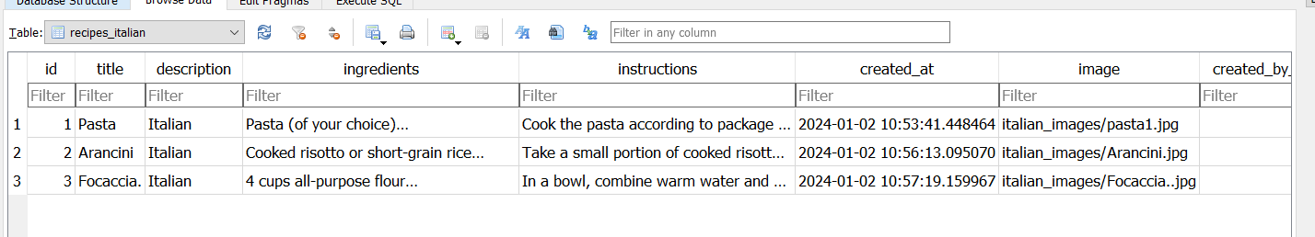

User Table: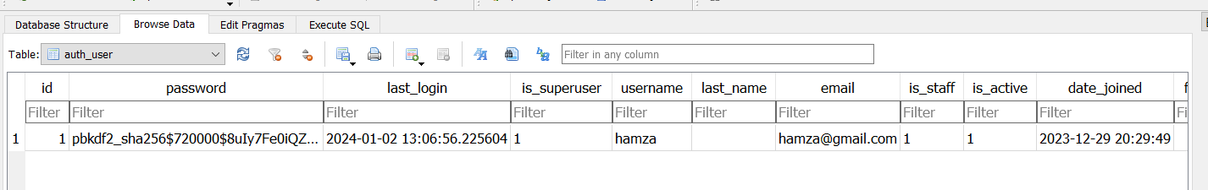

# RECIPE WEBSITE PAGES:

This website is created to layout the recipes of different cuisines food recipes, helping people how to cook and manage all kitchen stuff.

## **HOME PAGE:**

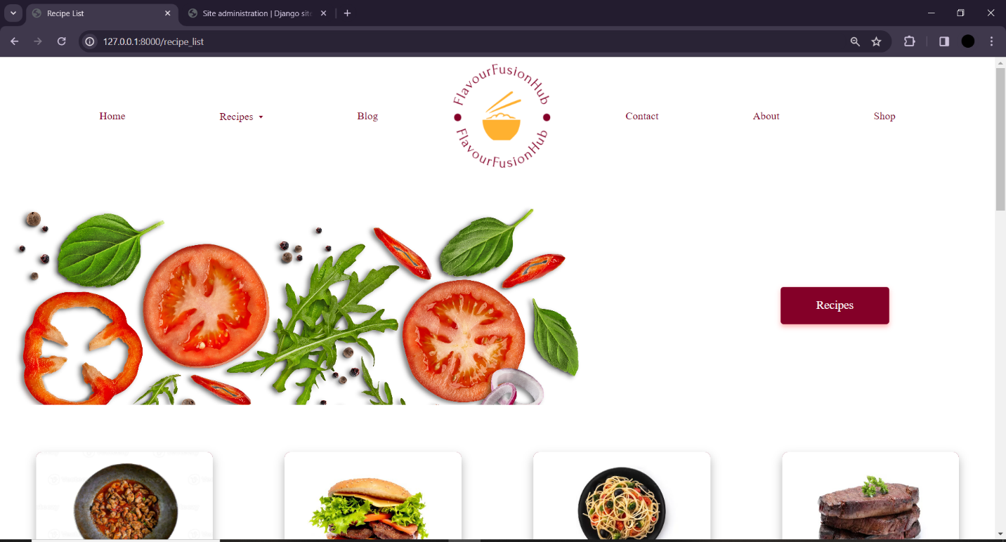

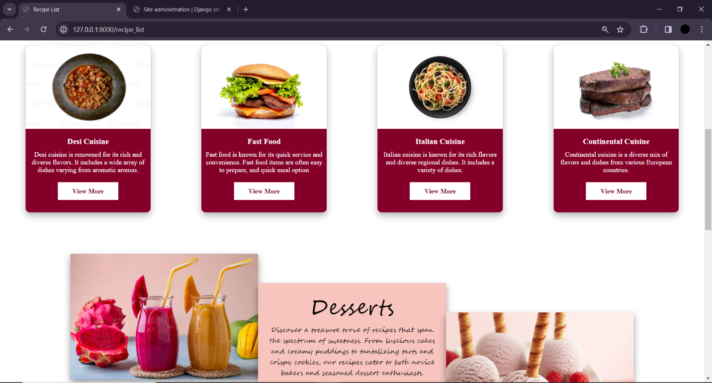

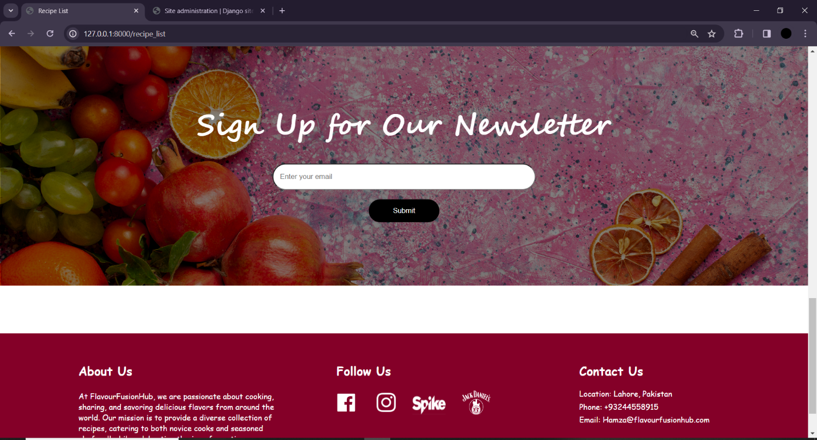

## **Code:**

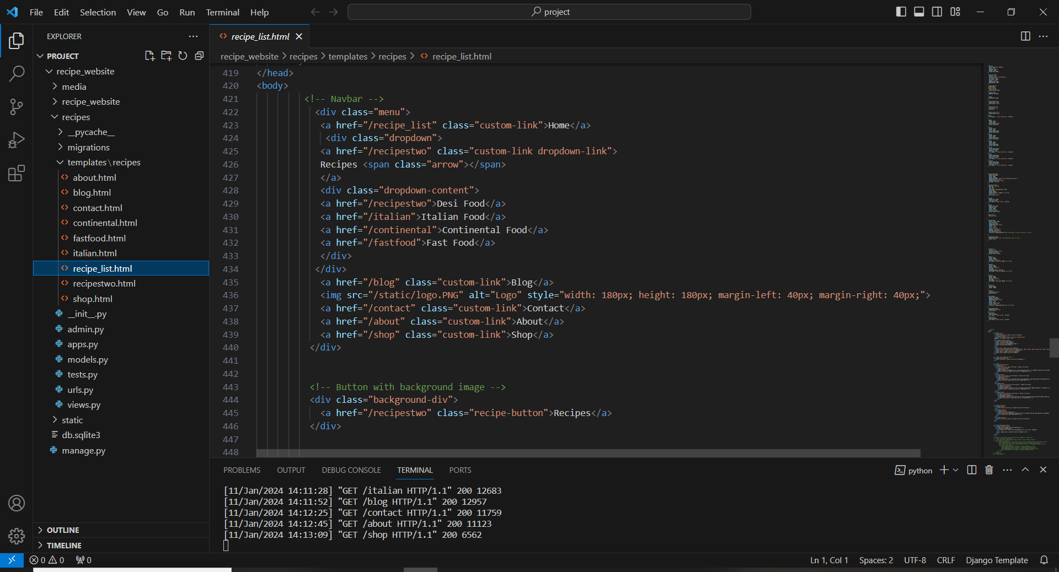

## **RECIPES LIST PAGE:**

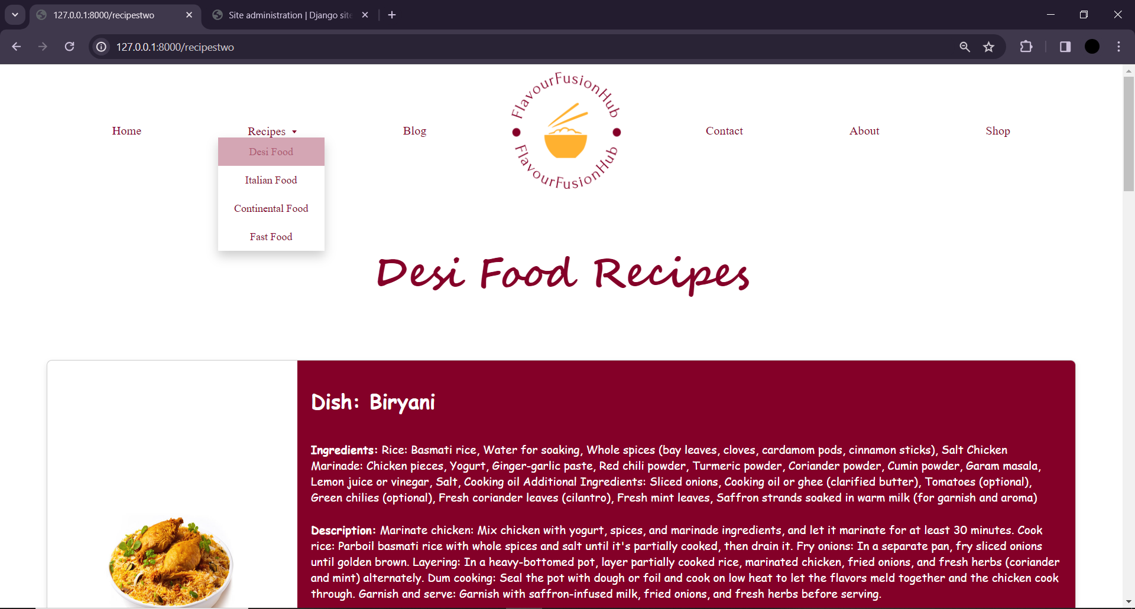

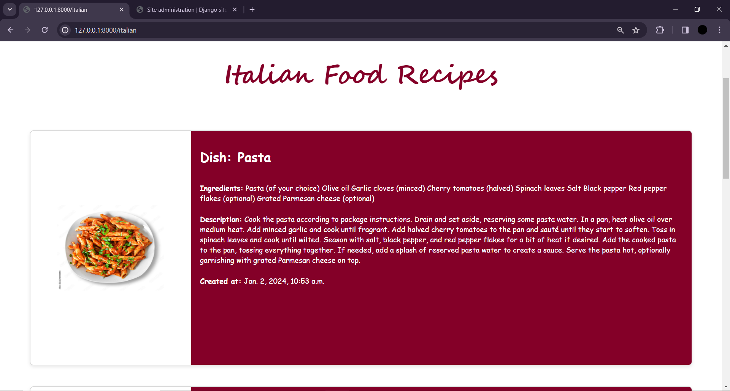

## **CODE:**

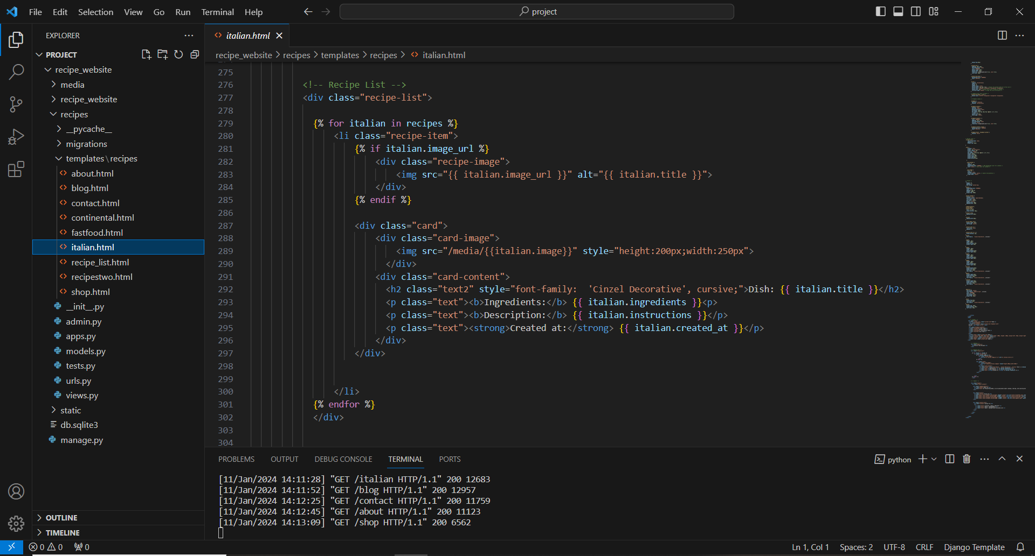

## **BLOG PAGE:**

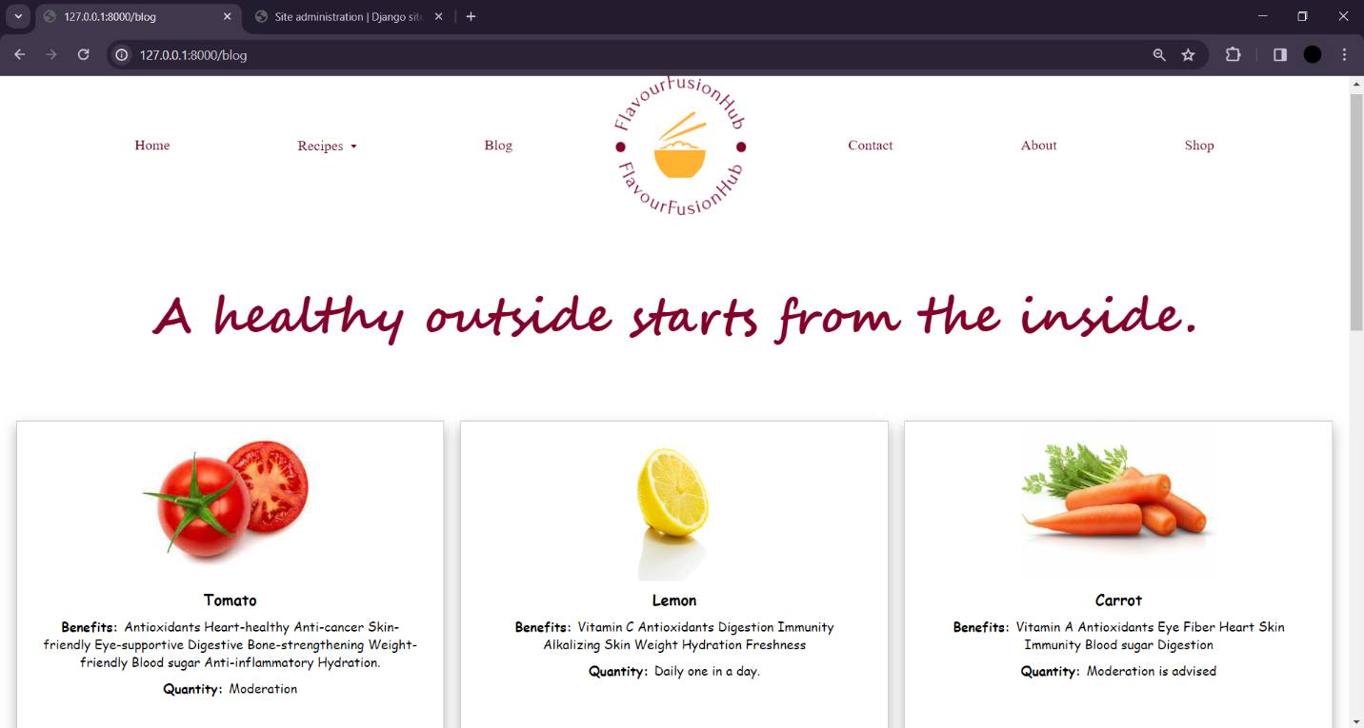

## **CODE:**

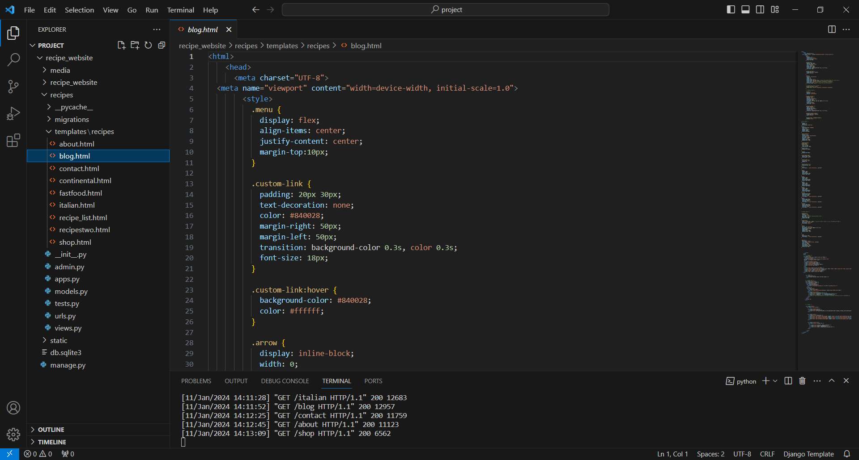

## **CONTACT PAGE:**

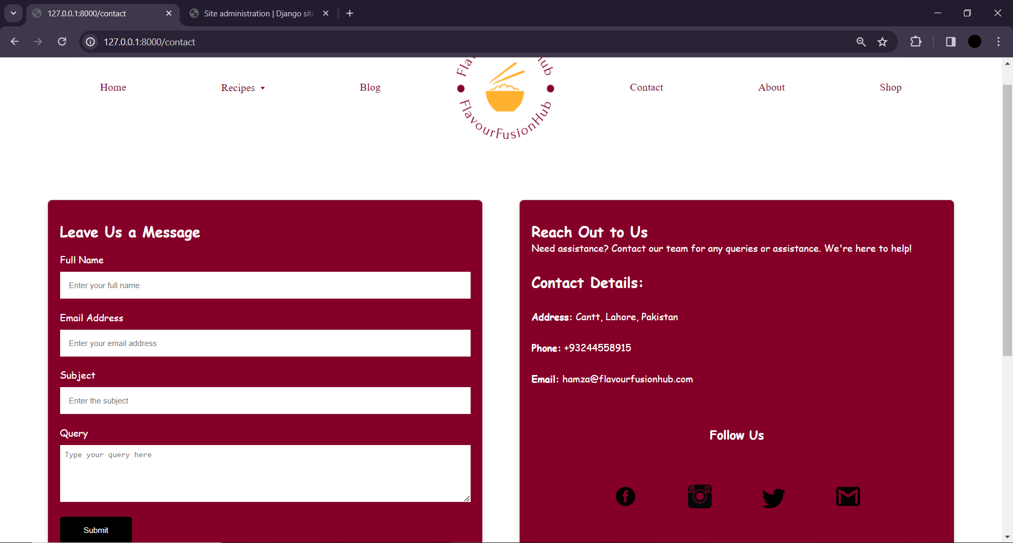

## **CODE:**

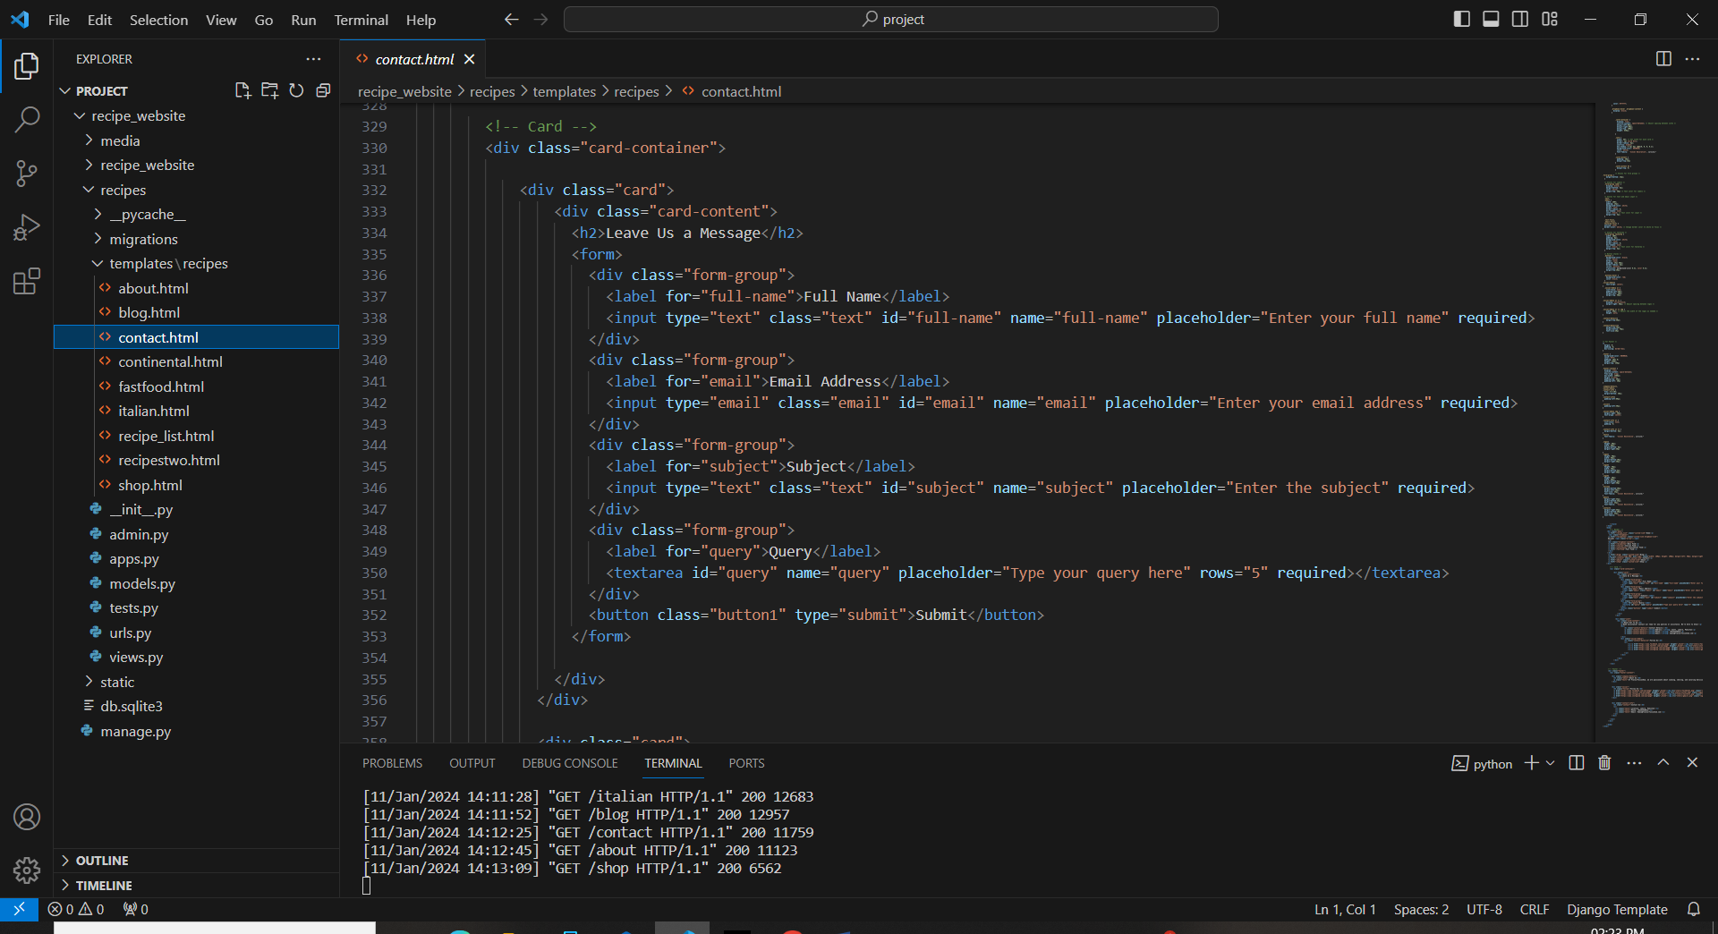

## **ABOUT PAGE:**

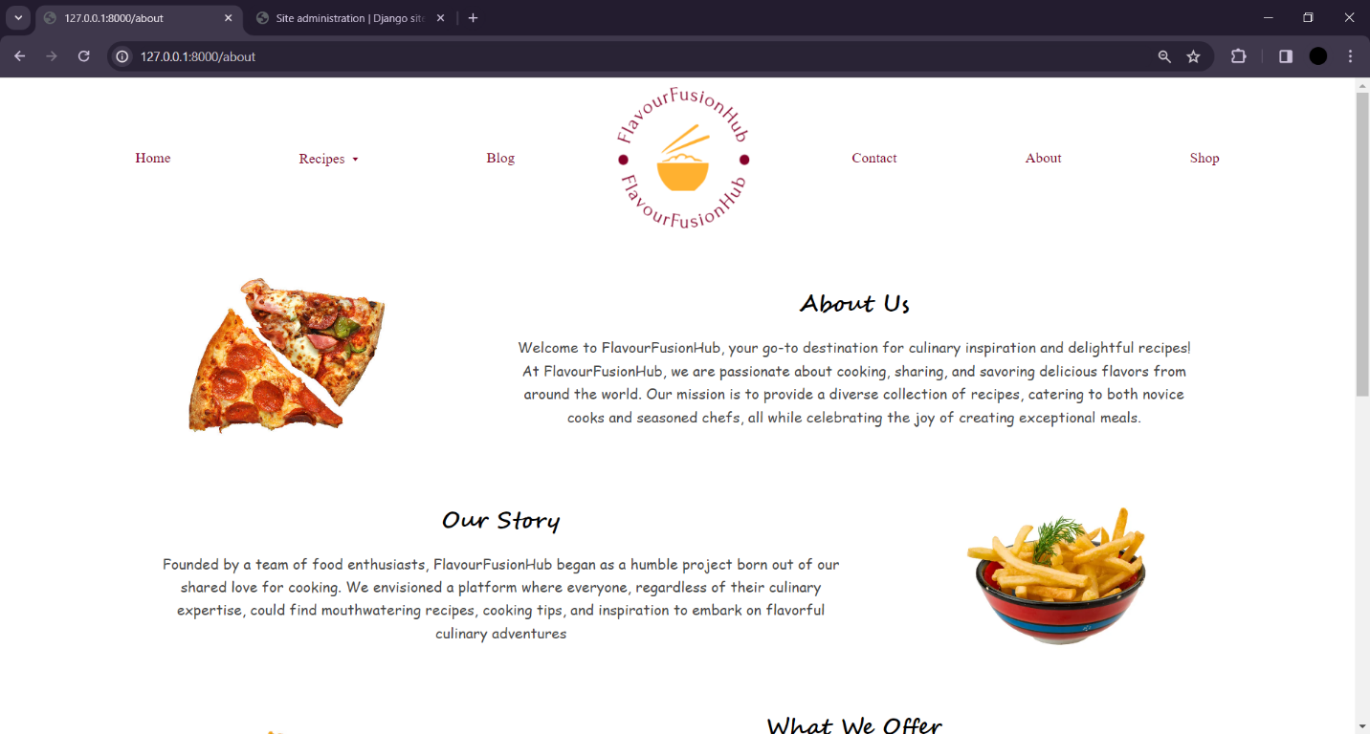

## **CODE:**

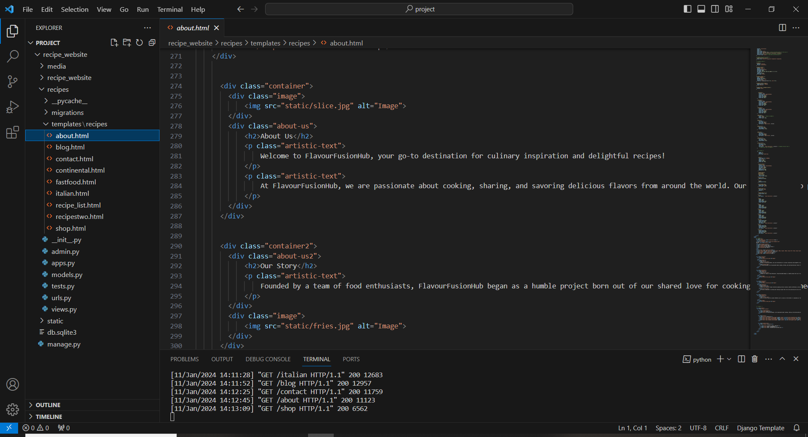

## **SHOP PAGE:**

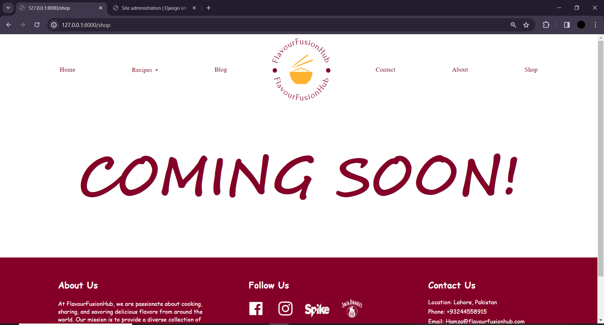

# **Summary:**

The website's backend prowess, driven by Django's architecture, empowers administrators to dynamically manage and curate the culinary content. With the ability to effortlessly create, edit, and delete recipes, administrators play a pivotal role in shaping the digital cookbook's evolving narrative. The SQLite database, a lightweight yet potent companion, provides a secure and efficient foundation for storing the wealth of culinary knowledge shared by users. This collaborative environment extends beyond recipes, allowing administrators to curate and maintain an engaging collection of blogs, adding a layer of narrative depth to the culinary experience.

The frontend, sculpted with the finesse of HTML and CSS, doesn't just present information but crafts an immersive visual journey. Each recipe becomes a visual feast, adorned with enticing images and layouts that spark culinary curiosity. The intuitive user interface, enriched by HTML and CSS, seamlessly guides users through various cuisines, dietary preferences, and cooking difficulty levels. It transforms the act of recipe discovery and sharing into a visually delightful and user-friendly experience.

Furthermore, the website's commitment to community engagement is evident in its user-centric features. From personalized profiles for contributors to interactive forums where culinary enthusiasts connect, the website fosters a sense of camaraderie.